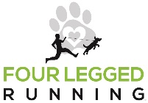
Make Your Own Race Shirt
FLR wants to make our races more affordable, sustainable, and eco-friendly. Knowing that many race swag items often end up in a landfill or get donated, we have chosen to forgo the standard "free" shirt included with your entry. We know that this is sad for many runners so we are providing you with FREE custom images to choose from that you can use to create your own race shirt or swag choosing the style and material of shirt or apparel you like best!! Use a Cricut or purchase iron on transfer paper from your favorite craft store to create your swag!
We can't wait to see how you make this race swag your own!
Right click to save each of the below as an image/picture and use how you wish!
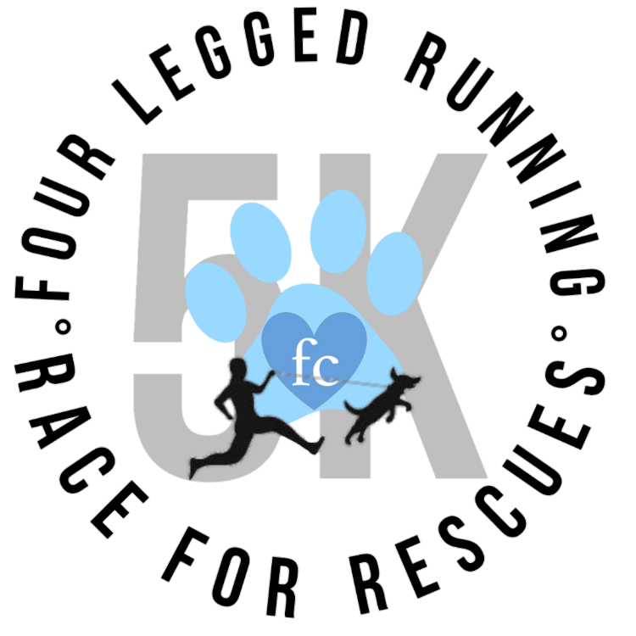
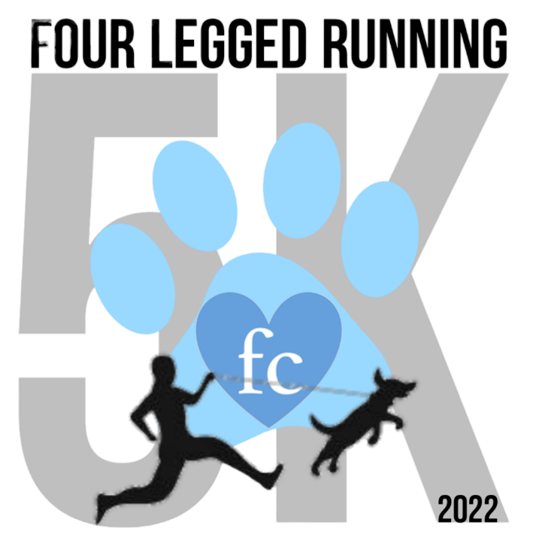
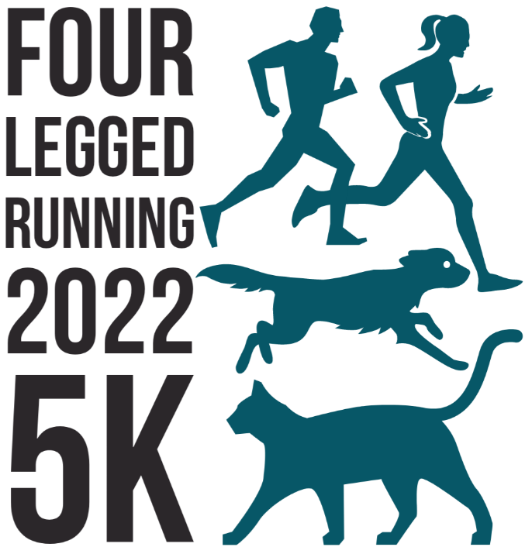

*Four Legged Running acknowledges that any user has rights to use these images.

